Table 1: Causes of papillitis
Causes of Papillitis
Multiple Sclerosis
Viral infection
Diabetes
Giant Cell arteritis
Hyperthyroid
Syphilis

Table 2. Ocular problems in syphilis infection
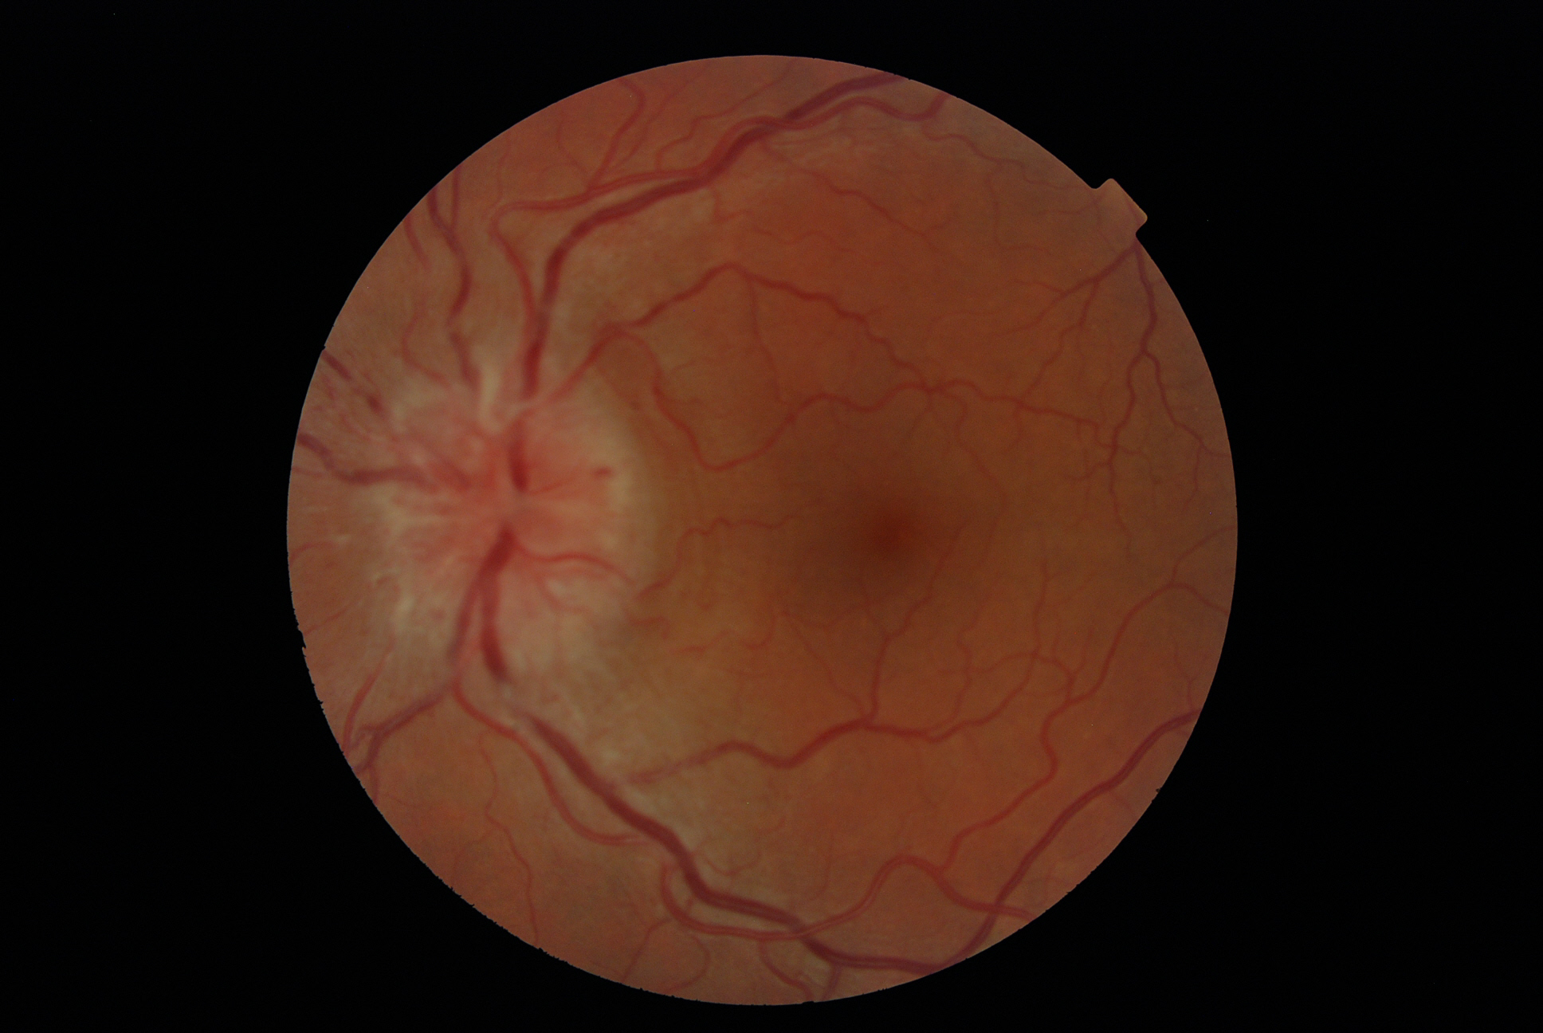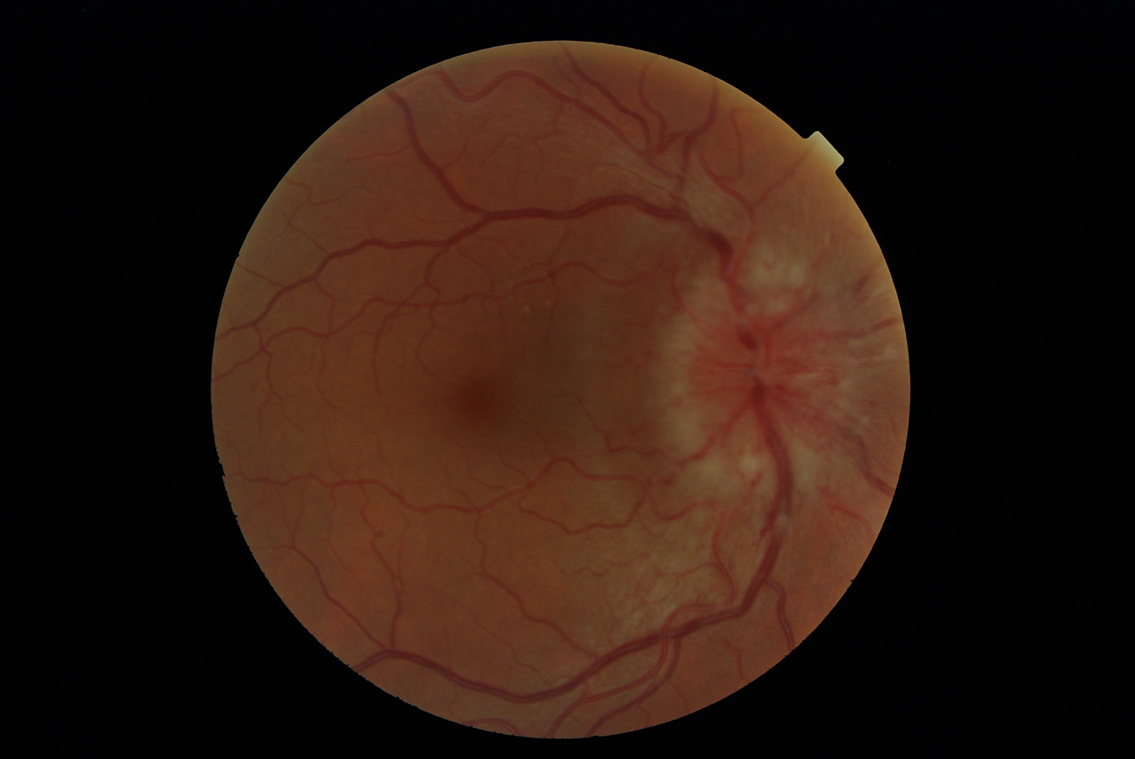
Ocular problems in syphilis:
Blurred vision
Reduced acuity
Reduced colour perception
Interstitial keratitis
Uveitis
Retinitis
Cranial nerve palsy

Figure 1: Indistinct optic disc margins but normal CSF opening pressure in papillitis

