Figures:
Figure 1: Transoesophageal Echocardiogram (TOE)
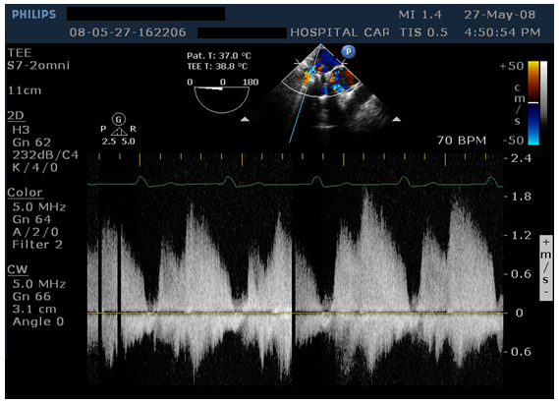

Figure 2: CT Angiography
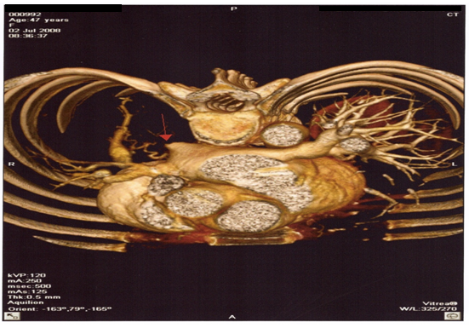

Figure 3: CT Angiography


