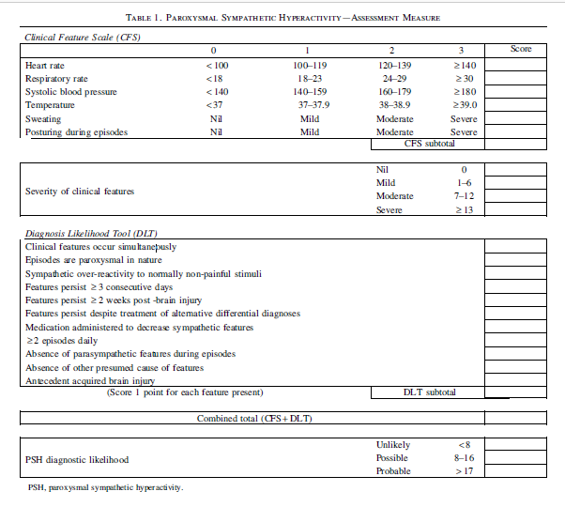
22
22
9
13
x
x
x
x
x
x
x
x
x
1
2
3
2
3
2
Figure 1-PSH assessment scale

