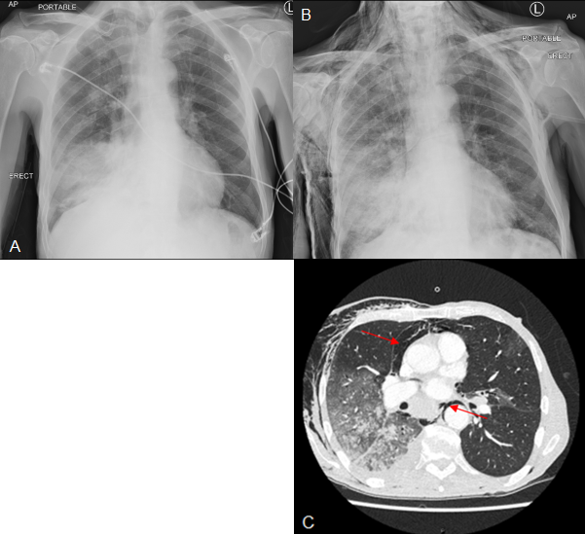
Figure 1 Chest radiology throughout admission.
(A) Admission chest film showing right lower zone consolidation.
(B) Repeat chest film showing extensive subcutaneous emphysema.
(C) Chest computed tomography showing pneumomediastinum (red arrows) and extensive right-sided lung consolidation.

