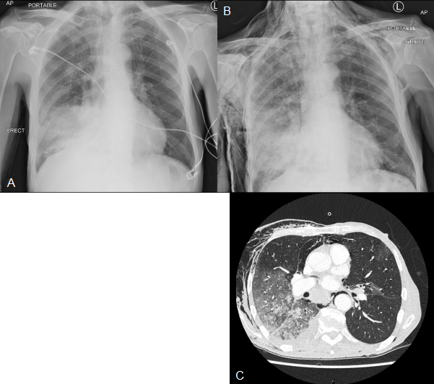
Figure 1 Chest radiology throughout admission.
(A) Admission chest film showing right lower zone consolidation.
(B) Repeat chest film showing extensive subcutaneous emphysema.
(C) Chest computed tomography showing pneumomediastinum and extensive right-sided lung consolidation.

